|  |  |
| --- | --- |
| **TEAM ID** | PNT2022TMID22828 |
| **PROJECT TITLE** | **SMART FARMER-IOT ENABLED SMART FARMING APPLICATION** |
| **NAME** | **KOWSALYA D** |

**ASSIGNMENT – 4**

**Write a code and connections in wokwi for ultrasonic sensor. Whenever distance is less than 100 cms "send" alert to IBM Cloud and display in device recent events.**

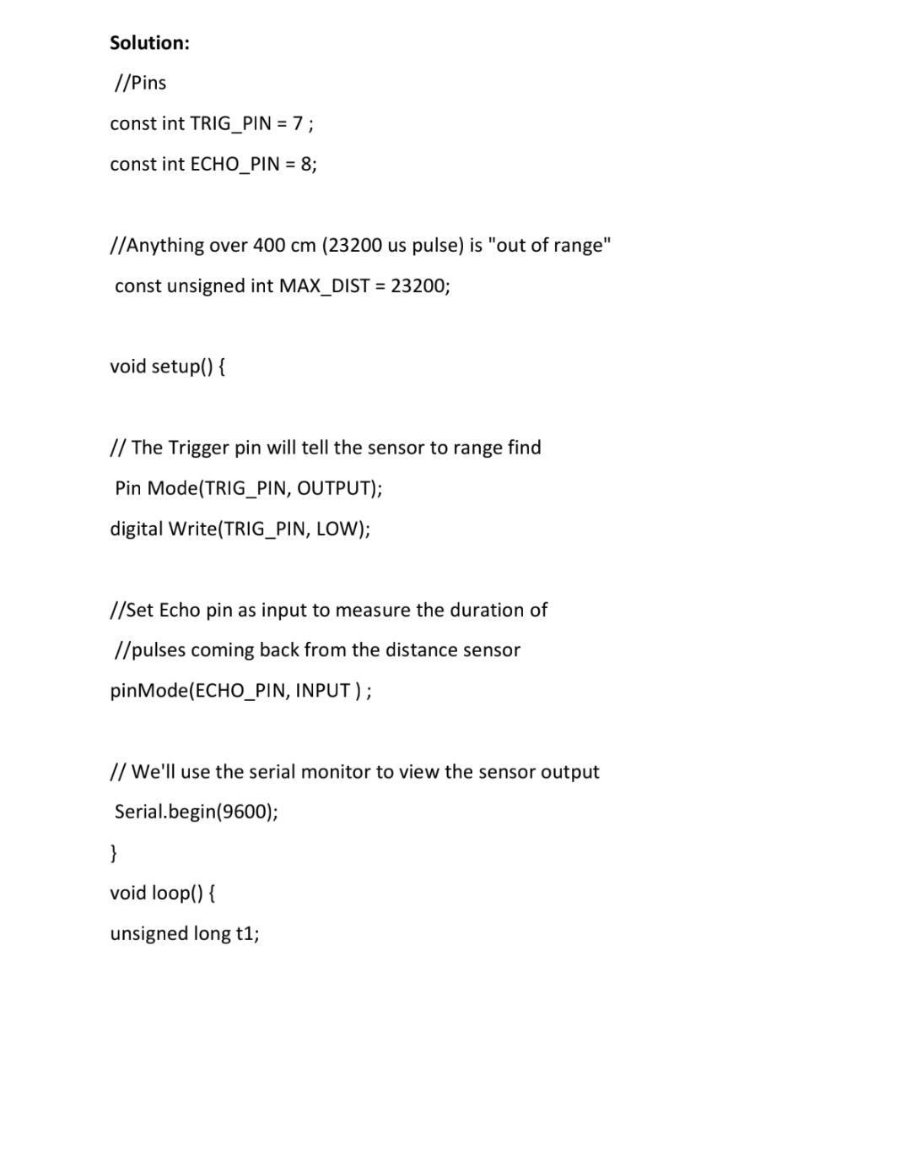

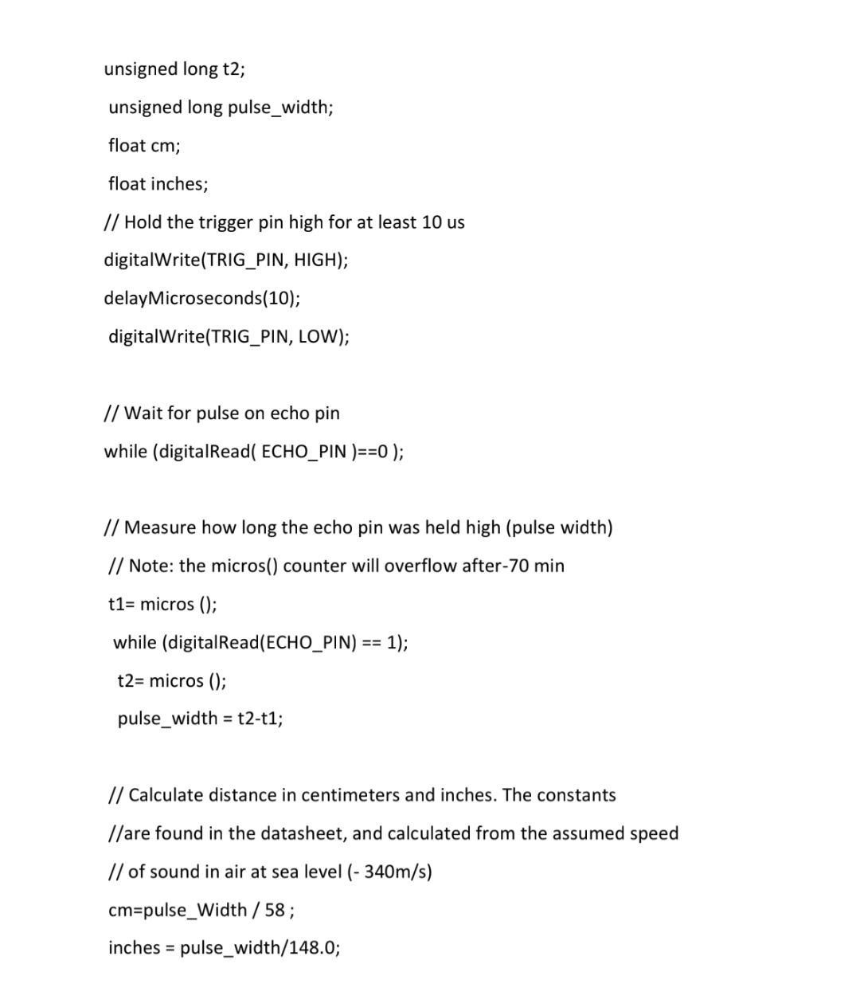

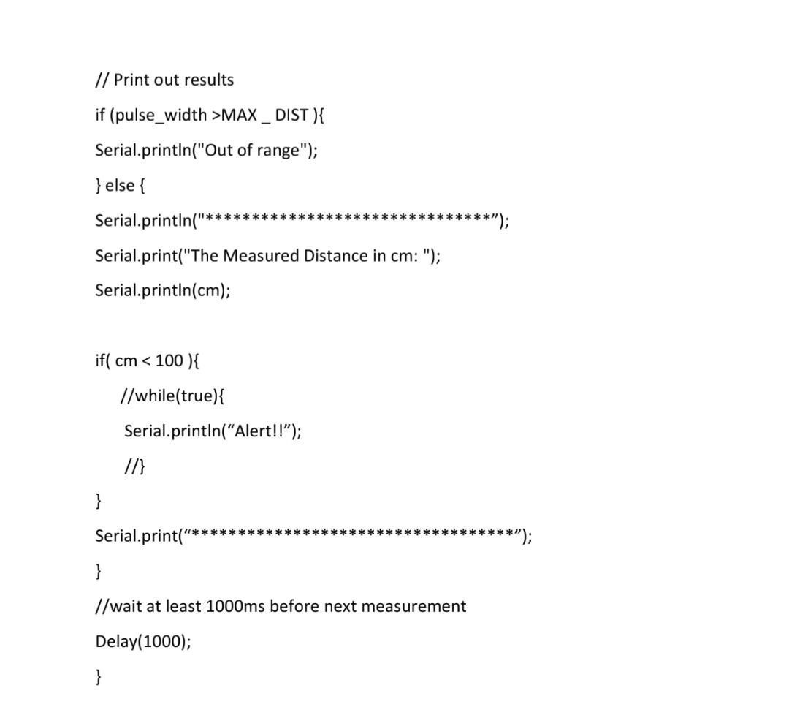

**OUTPUT:**

